Building the capacity of civil society in the Nuba Mountains
By Suleiman Rahhal
Between October 2007 and March 2008 Nuba Survival Foundation (NSF) in collaboration with Nuba Mountains International Association for Development (NMIAD) embarked on a capacity building project in the Nuba Mountains. The prime objective of this project is to build the capacity of civil sector and the community in the region. This is an important paramount to pave the way for building confidence, trust and peace between the Nuba and the Arabs tribes living in the region.
The long civil war in the Nuba Mountains region rendered the Nuba community vulnerable and driven to the brink of desolation. It also created much hardship, distrust and hatred between neighbouring communities, and caused enormous sufferings to the people of the area. As a result many innocent civilians were killed and tens of thousands were displaced and driven out of their homeland and became refugees in their own country. Today thousands of Nuba live below the poverty line, both in the Nuba Mountains and in other areas of the Sudan. Education, healthcare, community development and road infrastructures were virtually destroyed.
It is for these reasons Nuba Survival Foundation embarked on a capacity building project, supported and funded by the British Embassy in Khartoum. The project aims to build the capacity of this battered community, improving the quality of their lives, empowering them and strengthening the work of local Non-Governmental Organizations (NGOs) to adequately serve their community. It also aims to enable them to help resolve the local conflicts and work to bring a lasting peace to the region.
Over the past six months and under the slogan “Sustainable Peace and Development, for Peaceful Life and Brighter Future for the People of the Nuba Mountains”, the two organizations successfully held seven workshops on capacity building in the Nuba Mountains. At these workshops several important issues were debated: community development, gender, organizational management and leadership, good governance, conflict resolution and peace building, human rights, land tenure and environment.
The participants who took part in these workshops were leaders of the native administration (Amir, Meks, Omada and Sheikhs), representatives from local NGOs, political parties, youth activists and from the unity government (NCP and SPLM). The consultants and the facilitator were experts and highly specialized in their field. They delivered useful information, facts, data and analysis. It is without doubt that this has been extremely helpful in education and training for both the civil sector and the community, who previously lacked the opportunity to know these things.
Through these excellent presentations a vast amount of information was disseminated and the participants showed great interest in the issues under discussion. They gained considerable knowledge and benefited enormously from this work. For example, one participant made this remark:
“This has been an important educational programme for us here in the Nuba Mountains. The project came at the right time, following the slow recovery of the region from the effect of the long civil war and it is now entering another phase full of challenges ahead. This will of course require empowerment of the community to stand up and face these challenges. Therefore building the capacity of the community at this stage is of significant importance to the people of the Nuba Mountains”.
Over the six month period the following capacity building activities were carried out in the form of workshops and education:
Community Development:
At the community development workshop the deliberations drew the attention of the participants to the problems hindering the development in the Nuba Mountains. Among these are economic, social, administrative, legislative and political issues. In addition, small development schemes experience problems such as lack of capital for development, the inability to utilize the natural resources, the inability of local products to compete with foreign products, the lack of education and capacity for development. Although the vast majority of people in the Nuba Mountains are currently living below the poverty line, their region has great potential and is known to be rich in underutilized resources.

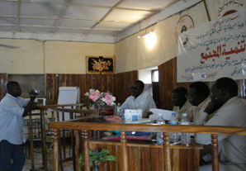
Community Development Workshop
Gender:
It became obvious that the gender issue was not clearly understood by many people and only a few women activists knew what the word gender meant. Much of the discussion revolved over men's domination of women, lack of equal opportunity and women's political rights. Women claim that since they represent more than 50% of the total population of the Sudan they call for greater representation in parliament.
They demand proportional representation and the 25% quota proposed by political leaders is not acceptable. Women in South Kordofan claim that they are discriminated against politically, economically and socially.
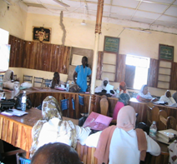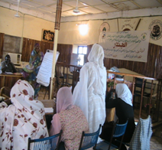

Gender workshop Gender workshop

This project has strengthened their cause and given them a platform to make their views and voices heard. Indeed, their contribution has made a great impact and women's attitudes have changed immensely in understanding their rights. At least they are now better equipped and ready to challenge authority for their basic civil rights, including their political rights. They demand that women should have a bigger say in “Popular Consultations”.
Organizational Management and Leadership
Organizational management was an issue of interest to both leaders of native administration and civil society organizations. Management, finance, transparency and teamwork are the main criteria for the success of the organization.
The conclusion of the workshops was that civil society organizations have a significant role to play in serving the communities and ensuring that their rights are recognized and maintained.
The findings from a questionnaire carried out revealed that the participants felt they had benefited considerably from the discussions as well as from the vast amount of information provided. However, some comments made by the participants pointed to the fact that there is a lack of training, funding and governmental support for the work of local NGOs.
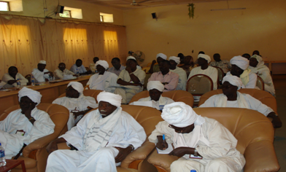
Good Governance:
Good Governance is based on human development that widens the chances and the choices for humans to achieve their objectives without intimidation. Human development in education and economics is important. Good Governance is based on various factors, including equality, participation, pluralism, solidarity, accountability, rule of law effectiveness, responsiveness, sustainability and equal opportunity. It is to be found in increasing capacity building of people and in widening their chances, choices, social, political, economic and cultural freedom of the marginalized and the poorest people in the community.
Good Governance has brought a new concept in the understanding of sovereignty of the state. This sovereignty is linked to human security in the form of collective security. As such the NGOs need to have a greater role in coordination with international organizations such as UN at the expense of the state. The participants discussed the concepts and the principles of Good Governance and concluded that its fundamental characteristics center on human rights and human development.
Conflict Resolution and Peace Building:
Conflict resolution and peace building were largely felt to be the most important topics and of great interest, particularly to the native administration, local NGOs, political parties and official from the government. Among the topics discussed were the root causes of the conflict in the Sudan, the Mashakos Protocol, Naivasha Peace Agreement and the future of Popular Consultations. The contributions made by the participants to the discussion revealed that many people in the Nuba Mountains still do not know the details of the CPA and they are confused over the issue of “Popular Consultations.” Many still believe that it is another name for self-determination, which it is clearly not. However, many participants believed that the people of South Kordufan were not represented properly at the peace talks and that too many compromises were made on the Nuba Mountains issues to reach the peace settlement between the Government (NCP) and the SPLA/M.

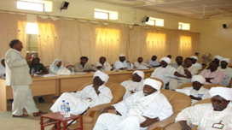 | 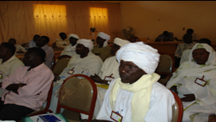
Conflict transformation and Peace building | Organizational management And leadership workshop
As far as post conflict transformation and peace building are concerned the leaders of the native administration contributed to the discussion by giving their experience in resolving disputes and conflict between the tribes. However, today their power has been reduced and they can no longer resolve even small disputes. In the past, during British rule in Sudan, leaders of the native administration were able to resolve even serious conflicts because they had power and were able to apply customary law.
Human Rights:
The human rights workshop generated considerable interest and was one of the liveliest issues under discussion. In their deliberations the participants discussed the bill of rights, the human rights charter, international human rights law, international covenants and women and children's rights.

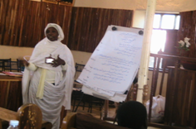 | 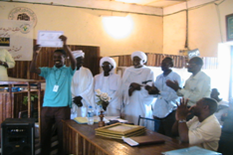
Human rights recommendations | Certificate Award
Some of these issues were new to many of the participants, one commented: “Now we know our rights and we know how to achieve them”. People in this region have suffered enormously from grave human rights violations but they did not previously understand human rights laws and how to present their grievances. Now people have begun to understand the concept of human rights.

Land Tenure:
Land tenure is an essential issue as land is one of main factors that contributed to the long years of war in Sudan. Like many countries in Africa, Sudan faces tremendous problems with land tenure. Before this capacity building programme only few indigenous Nuba understood land tenure laws, land rights and land registration. People in this region believe that lands are communal and belong to community and not to the government. Only recently did people begin to hear about land registration. The central governments in Sudan since 1970 have introduced aggressive laws that denied the indigenous Nuba their customary land rights, which was one of the root causes for the long conflict in the Nuba Mountains. The unregistered land in the Nuba Mountains held under customary laws is not recognized or respected by the government. The participants discussed laws related to land tenure and the land sequestrations since 1902. It was indicated that these laws dated from the time of Lord Kitchener who introduced the first land tenure laws and land registration in 1899 in the northern Sudan.

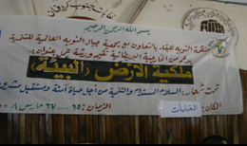 | 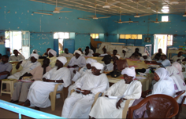
Land Tenure and Environment Workshop | Participants at land Tenure workshop
This gave the northern Sudanese community the right to register their lands. However, such rights were not extended to include the Nuba Mountains and other parts in the Sudan. Today there are demands by the leaders of native administration for the demarcation of the Nuba Mountains as well as for land registration offices to open for people to register their land before the government expropriates it.
Several issues including land laws, customary laws, land registration land sequestration and the land commission were debated, and many questions were raised. Among these were why there are two types of land tenure laws in the country (one in northern Sudan and different one in Nuba Mountains? Why customary laws are not incorporated in the new land laws and in the constitution? Why people in the Nuba Mountains whose lands had been confiscated by the government were not compensated? Finally, why the land Commission stipulated in the CPA for South Kordofan has not yet been formed to look into land problems? Such questions raised by the participants reveal that the peoples' knowledge and understanding of the land issue have increased as the discussion progressed.
One positive outcome of the land tenure workshop is that the leaders of the native administration called for a meeting in Kadugli to discuss land tenure problems, including the sequestration without compensation of land belonging to indigenous Nuba.
Environment:
Environmental protection has been an issue of concern because community lives depend on the natural environment and its resources for sustainable development. People clearly understood that any damage to the environment will put lives at risk. The paper presented highlighted the importance of environment protection. Participants were concerned about the damage caused by oil companies and they recommended that international environment protection laws should be put into effect in a country like Sudan. Before this workshop the community in the Nuba Mountain generally knew very little about the environment and its protection. What people here want is rain. However, the workshop emphasized the need for the community to be taught how to protect their environment on which they depend for water, grazing, forestry and agricultural products.

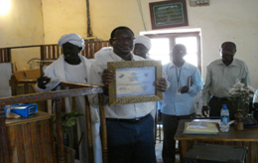 | 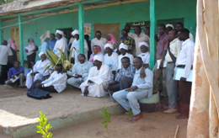
A presenter given award | Participants
Conclusion and outcomes:
To conclude, we have noticed that the project has made a significant impact on the community in South Kordofan. One outcome is that knowledge and the profile of the civil sector and the community have risen immensely. This can clearly be observed from the comments and remarks made by the participants at the end of the capacity building programme, which signifies how successful the project has been in meeting its aims and objectives.
Through education, training and discussions performed in this project it is clear that the knowledge and the understanding to the issues discussed such as land tenure and environment have increased by 80% among the community leaders and 90% in the civil sector, which can be considered quite an achievement in a very short time. The project also contributed significantly in promoting the profile of local NGOs by supporting and strengthening their work and raising the level of their management skills. This certainly will enable them to play their role effectively and efficiently, particularly in providing adequate services to the needy community, empowering and prepare them for the challenges ahead, including the general election which we hope to be free and fair. However, many people are very much concerned whether there will be a true multi-party democracy in the country in the lead up to the elections.
The comments and remarks made by the participants in evaluating this capacity building project can be considered as another indicator of the success of the programme and I quote here some of their comments:
1. “This capacity building project is considered to be one of the important projects for the people of the Nuba Mountains. It is equally important for the leaders of native administration. All the topics discussed considered to be of significant importance for the region, particularly in conflict prevention because today there are recurring conflicts in the region, which require leaders of native administration to have knowledge and understanding how to resolve these conflicts”.
2. “On the issue of land tenure many people who participated in this workshop did not know land tenure laws. However, through the workshop and deliberations they become more relax and appear to understand these laws. I believe the impact of this capacity building will be seen soon in the change of attitudes of the people in this region”
3. “The direct impact of this workshop has been noted in the reactions of the people to the facts, data and information provided which people did not know before, particular about land registration and the ‘special provision’ given to the people in the northern Sudan as far as land registration is concerned while the people in he Nuba Mountains were not told about land registration or given that ‘special provision”
4. “The capacity building project from the evaluation point of view can be considered as one of the important workshop held in the Nuba Mountains so far. People of the Nuba Mountains need this kind of workshops to enlightening them because the war period was a disaster for the Nuba people. During the war people did not know anything expect war and to escape from death. However, at this peace time and through this kind of workshops the knowledge and information for example about conflict prevention can be available to the people in particular to the leaders of native administration”.
5. “The land tenure is an important issue for all. People in the Nuba Mountains depend solely on land and their lives are associated with land which they have inherited through customary laws. Before this workshop people in the Nuba Mountains did not know about land registration or about land rights. Through deliberations we come to learn about the important issues such as land ownership, environment protection and human rights, particularly about laws”.
Many recommendations were made for all the issues discussed which can be found at the narrative report submitted to the donor. However, many people called for more of this kind of capacity building to strengthen the civil sector work and to empower the community in order to stand up and challenge authority for their basic civil rights as well as to work to achieve a lasting peace for the people of the Nuba Mountains region.
We believe that this capacity building project has made an impact on the people in the Nuba Mountains by promoting the capacity of the civil sector and community on several fronts. However, the future of the Nuba Mountains is uncertain, as the political issue is still far from being resolved and it needs to be addressed. Naivasha Peace Agreement has failed to address the grievances, the aspirations and the demands of the people of the Nuba Mountains. The international community should not only focus on the crisis in Darfur and Southern Sudan ignoring the issues of other marginalized regions in the Sudan, including Nuba Mountains.
During our capacity-building work we found a large number of people not satisfied with the CPA and there are burning resentments among many people in the Nuba. People are extremely worried about their future in the Sudan, particular if the people of Southern Sudan decided to opt for independent South at the referendum. This means they will leave behind the Nuba vulnerable and at greater risk. The international community should not ignore the Nuba Mountains issue. People in the Nuba Mountains are desperately in need of development, security and empowerment. The current political development in Sudan puts The future of the Nuba people in at stake. This means they will depend solely on the support of the international community, particularly from countries like the United Kingdom which appreciate the Nubas' sticky situation in present day Sudan.
It is clear that much work remains to be done prior to elections and the proposed “popular consultation” stipulated by the CPA. We have come to understand that the vast majority of the Nuba consulted had very little idea of either the terms of the CPA or the mechanics of elections, democracy and referenda and it is obvious that people will be unable to make informed choices if they don't understand the issues or the process under which they should be consulted. We therefore hope to secure future funding for a series of popular awareness workshops to extend the process to ensure proper grass roots participation in political decision making.
We are in a process of disseminating the findings of the activities carried out so that a large number of people can benefit from the information, laws and the recommendations made. Target groups will include the donor, local and international NGOs, human rights organizations, academic institutions, government officials and most importantly the community in the Nuba Mountains.
Finally, we would like to thank the British Embassy in Khartoum for its support and for funding this project under Sudan Peace Building Programme Fund. We also would like to extend our thanks and appreciation to David Hinchon and last but not least we extend our thanks and gratitude to Christine Jaguru Jasten, whose help and guidance throughout the project have been immense and invaluable to us.

